|  |
| --- |
| Time Travel Games |
| **Speed Runner 2** |
| **Keep moving or die** |
| Version #01  All work Copyright © 2012 by Time Travel Games.  All rights reserved. |
| **Aaron Fernandes** |
|  |

|  |
| --- |
| May 16th 2016 |

**Table of Contents**

[Your Table of Contents should go here. Make sure that your document’s sections are hyperlinked to their corresponding pages.]

**Version History**

GitHub Link: <https://github.com/aagavin/platformer2D>

1. **Game Overview**

The objective of the game is to keep moving or you die. When the player stops moving they lose time at a faster rate than when they are moving.

1. **Game Play Mechanics**

The player will go through the level and avoid jumping enemies, moving enemies and falling enemies. The player will also avoid traps that will reduce the amount of time.

1. **Camera**

The camera is in orthographic view and will follow the player

1. **Controls**

The player will use the a, and d keys to move left to right and the spacebar to jump.

1. **Interface Sketch**

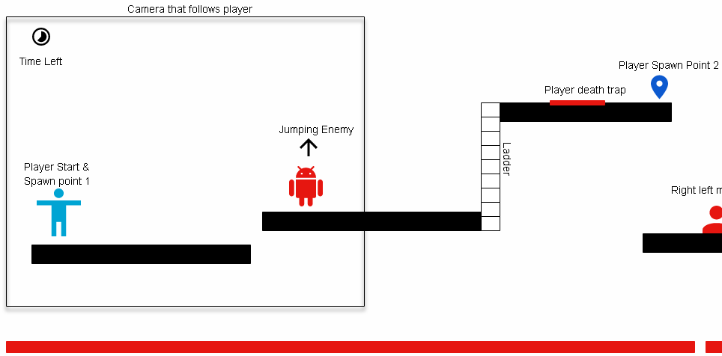

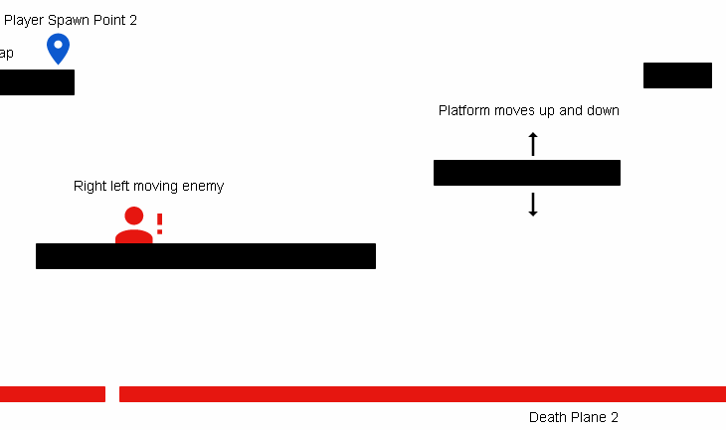

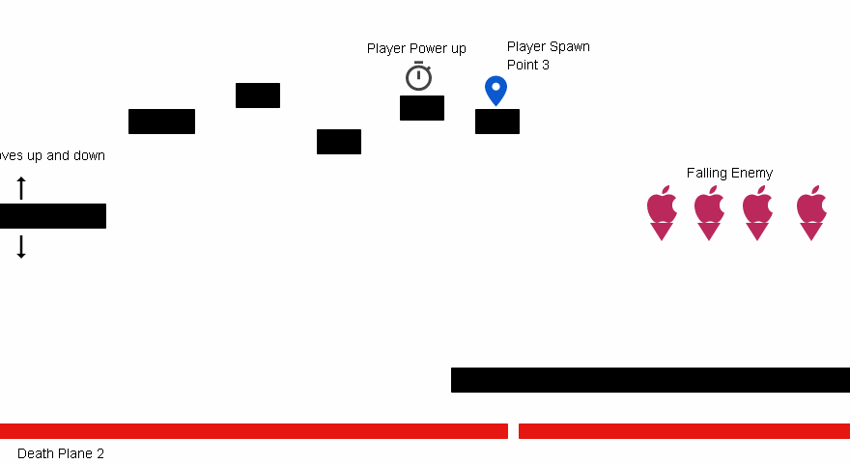

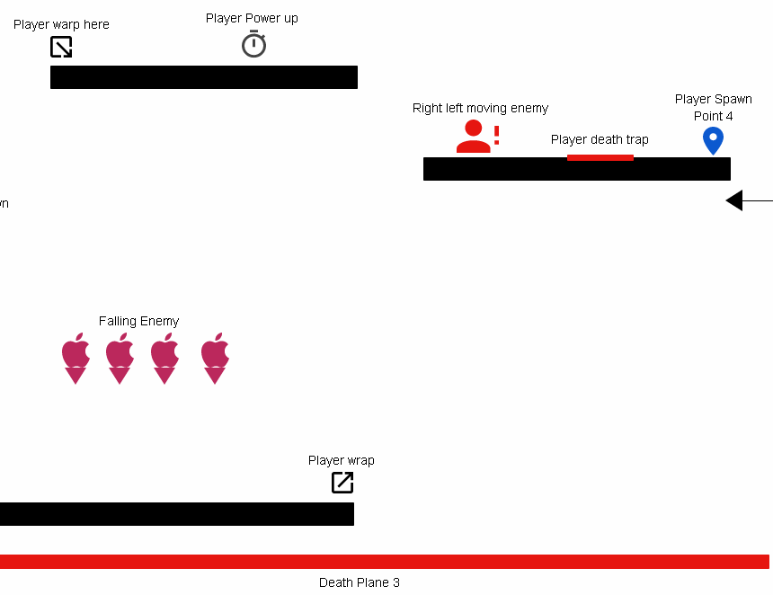

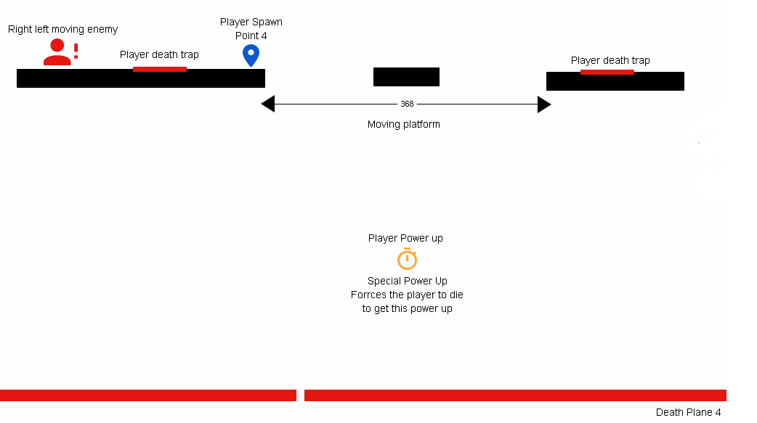

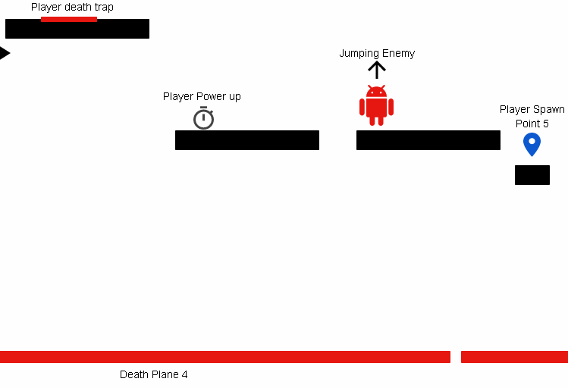

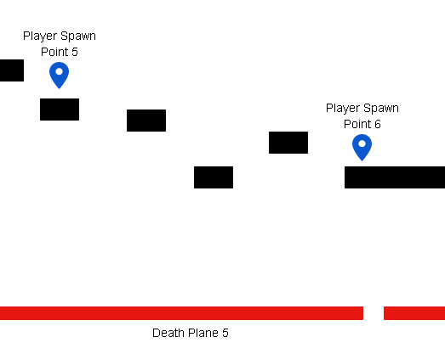

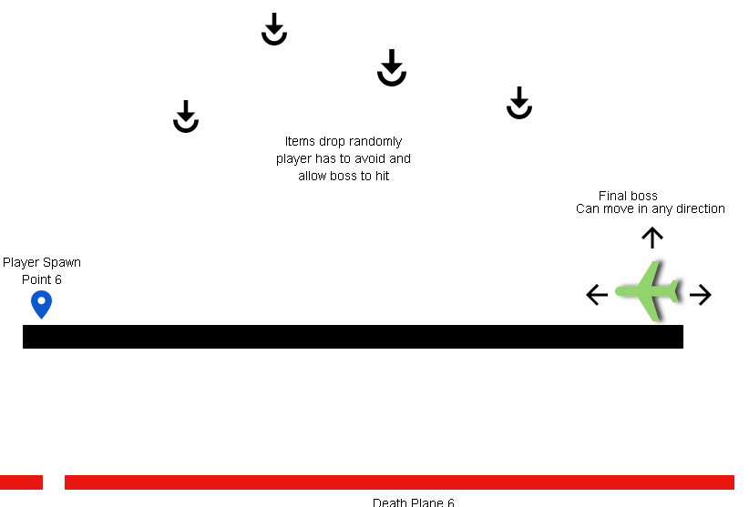

Link: <https://app.moqups.com/aagavin/YtxEOKhDZF/view?ui=0>

1. **Menu and Screen Descriptions**

*(Include additional screen shots and accompanying descriptions for any menus and additional screen)*

1. **Game World**

*(Describe Your Game Environment)*

1. **Levels**

*(Describe Each of your game levels)*

1. **Game Progression**
2. **Characters**

*(Describe Your game avatar if applicable)*

1. **Non-player Characters**

(Describe Any Computer controlled Allies and how they work)

1. **Enemies**

*(Describe computer-generated enemies and boss monsters)*

1. **Weapons**

*(Describe any weapons available to the user)*

1. **Items**

*(Describe any in-game items that can help or hinder the user)*

1. **Abilities**
2. **Vehicles**
3. **Script**
4. **Scoring**
5. **Puzzles/Mini-games**
6. **Bonuses**
7. **Cheat Codes**
8. **Sound Index**

*(Include an index of all your sound clips)*

1. **Story Index**

*(Outline your game story here)*

1. **Art / Multimedia Index**

*(Include an index of all your graphic and video assets here)*

1. **Design Notes**

*(Include additional design notes here)*

1. **Future Features**

*(Include any future features that are planned to be implemented)*